- Setup WSL and Docker
- Do the mandatory software installation
- Install Windows Certificate (CMF & TFS-Projects)
- Ensure Git installed properly
- Open REPO URL https://tfs-projects.cmf.criticalmanufacturing.com/ImplementationProjects/IKEA/_git/MES and ensure its HTTPS secured
- Open the Run command and ‘%USERPROFILE%’ command and create one new file ‘.gitconfig’
- Open PowerShell and Run the command “git config --global --list” and ensure following values are returned
  - http.sslbackend=schannel (This line responsible to make sure SSL certificate will be considered from trusted root authorities of windows)
  - credential.helper=wincred (This line to maintain Git credential in windows credential manager)
- If any one of the config is not available add manually using below command
  - git config --global http.sslBackend schannel
  - git config --global credential.helper wincred
- you can remove the git global config using below command
  - git config --global --unset http.sslBackend
  - git config --global --unset credential.helper
  - Run the command “git config --system --list” and ensure there is no ‘credential.helper’ entry, if the command gives error message it’s okay to proceed, if entry found kindly remove using command ‘git config --system --unset credential.helper’ since this entry gets conflicted with global setting
- Open ‘Manage Windows Credential” application from Windows Search
- Click on ‘Add a generic credential’ button
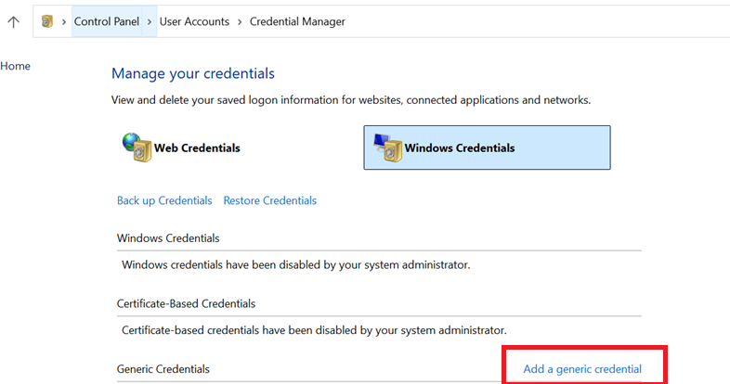
- Add a new generic credential entry like below
  - URL: git:https://tfs-projects.cmf.criticalmanufacturing.com
  - Username: CMF\<YOUR CM USER ACCOUNT>
  - Password: <YOUR CM USER ACCOUNT PASSWORD>
- Add a second new generic credential entry like below
  - URL: git:https://CMF\<YOUR CM USER ACCOUNT>@tfs-projects.cmf.criticalmanufacturing.com
  - Username: CMF\<YOUR CM USER ACCOUNT>
  - Password: <YOUR CM USER ACCOUNT PASSWORD>
- Close and Open the Visual studio & Make sure CM VPN connected & Now we should able to clone the repository
- Once Clone Completed, Open Windows Explorer or Run command and open ‘ ’ & Enter the CMF admin account details (Currently Selva & Sathish has Admin rights), once network location connected, you will get the screen like below
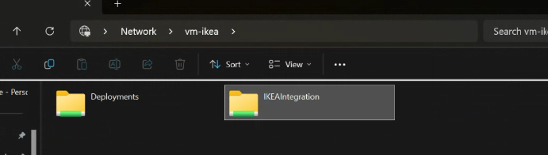
- Open PowerShell inside your REPO tools folder, In my case it is ‘C:\Selvaa\IKEA\Environment\MES\Tools’ & Run the command ‘.\Local_GetLocalEnvironment.ps1’
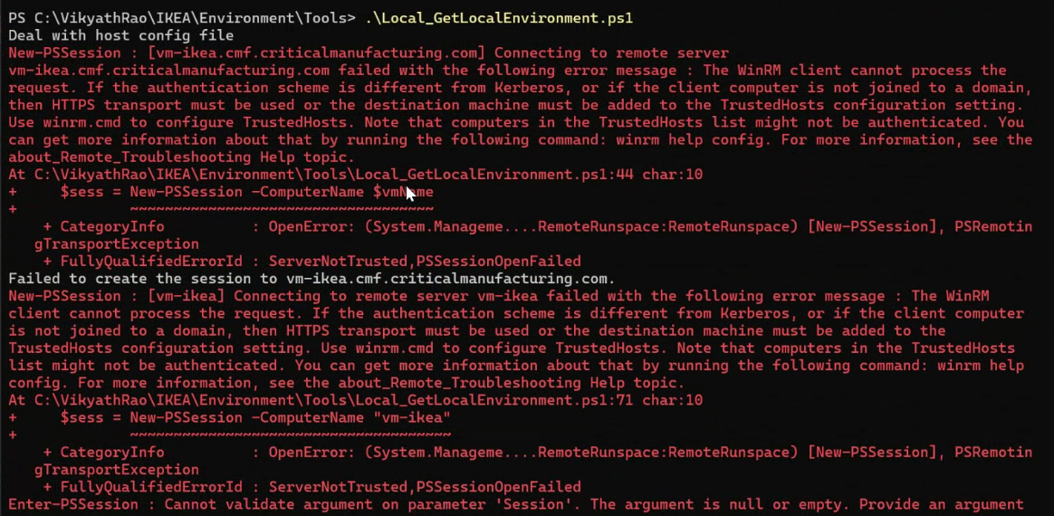
Ignore the above errors and wait for copy complete.
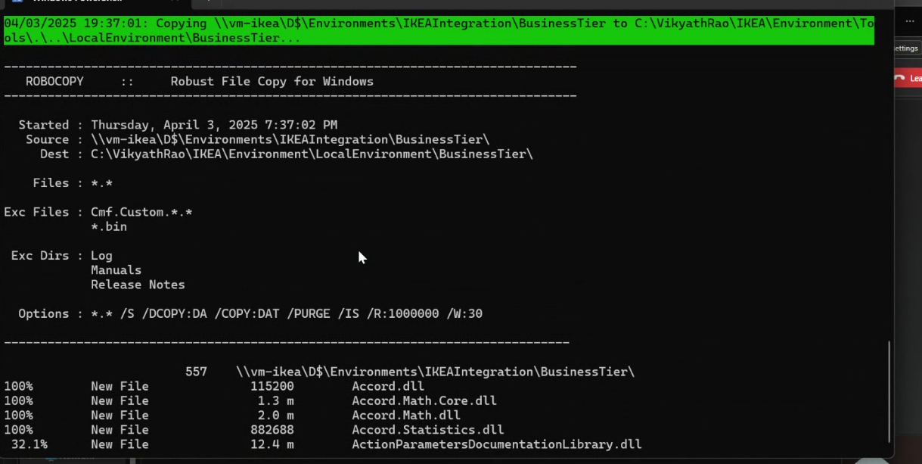
  - Enter ‘n’ and continue
  - If below kind of message asked, Kindly press Enter key, If password asked to provide your TCS account password.
  - In case of any error like below, kindly press Ctrl + C and stop the further execution and start the command again.
- Make sure you have following file in the path of ‘C:\Users\2817675\Documents\WindowsPowerShell\Microsoft.PowerShell_profile.ps1’ with proper file
Attached the file below
- Make sure WSL is running
- Open the windows path ‘\\VM-MS-DB-DEV\Backups\IKEA\IKEAIntegration’ and enter admin user credentials (currently Selva & Sathish has admin privileges)
- Run the following commands
wsl sudo mkdir -p /etc/docker/certs.d/mcr.microsoft.com
wsl sudo cp /etc/ssl/certs/ca-certificates.crt /etc/docker/certs.d/mcr.microsoft.com/
wsl sudo service docker restart
wsl sudo nano /etc/docker/daemon.json & Add the following line into daemon.json ‘{"insecure-registries":["mcr.microsoft.com"]}’ and save
wsl --shutdown & restart powershell wsl
- docker pull mcr.microsoft.com/mssql/rhel/server:2019-CU10-rhel-8
  - If the above command failed due to Zscaler blocks, contact supervisor to connect with IT team and get this component installed.
- Need to run the command ‘.\Docker_CopyOnlineDB.ps1’ under tool folder. And wait for proper container creation.
- Open Business Solution& Build Business Solution
- Open PowerShell from UI/HTML folder and run the following commands
  - npm install
  - Edit the package.management.js file under UI/HTML/node_modules/@criticalmanufacturing/dev-tasks/install
  - Search the ‘error’ and change into ‘verbose’
  - gulp install –-update ,if you receive gulp is not recognized, then run this command ‘npm install gulp -g' then the first command.

  - gulp build
  - gulp start
- Replace the ‘Cmf.Foundation.Services.HostService.dll.config’ file from the below path ‘C:\Selvaa\IKEA\Environment\MES\LocalEnvironment\BusinessTier’
- Change the following tags in the config file (Cmf.Foundation.Services.HostService.dll.config) and change the below paths
<DocumentManagement>
<add key="ArchiveFileShare" value="C:\Selvaa\IKEA\IKEAIntegration\Shares\Document\Archive" />
<add key="PermanentFileShare" value="C:\Selvaa\IKEA\IKEAIntegration\Shares\Document\Permanent" />
<add key="TemporaryFileShare" value="C:\Selvaa\IKEA\IKEAIntegration\Shares\Document\Temporary" />
</DocumentManagement>
<AttachmentManagement>
<add key="ArchiveFileShare" value="C:\Selvaa\IKEA\IKEAIntegration\Shares\Document\Archive" />
<add key="PermanentFileShare" value="C:\Selvaa\IKEA\IKEAIntegration\Shares\Document\Permanent" />
<add key="TemporaryFileShare" value="C:\Selvaa\IKEA\IKEAIntegration\Shares\Document\Temporary" />
- Change the following tag in the config file (Cmf.Foundation.Services.HostService.dll.config) and change the below path
<add key="RfcTraceDirectory" value="C:\Selvaa\IKEA\IKEAIntegrationRfcTrace.Log" />
- Modify the username and run the ADD_LOCAL_USER.sql script

For UI
Help build
1. npm install

error
npm cache clean --force
npm config get registry

if error the edit the nprc file add @criticalmanufacturing:registry=https://criticalmanufacturing.io/repository/npm/

How to change the nvm version

nvm use 12.22.12

